**DAILY ONLINE ACTIVITIES SUMMARY**

|  |  |  |  |  |  |  |  |
| --- | --- | --- | --- | --- | --- | --- | --- |
| **Date:** | **20/05/2020** | | | | **Name:** | **Imran Khan** | |
| **Sem & Sec** | **8th A** | | | | **USN:** | **4AL16CS040** | |
| **Online Test Summary** | | | | | | | |
| **Subject** | | **IOT** | | | | | |
| **Max. Marks** | | **30** | | **Score** | | **27** | |
| **Certification Course Summary** | | | | | | | |
| **Course** | **Angular and node js –The mean stack** | | | | | | |
| **Certificate Provider** | | | **Udemy** | **Duration** | | | **20hrs** |
| **Coding Challenges** | | | | | | | |
| **Problem Statement: Write a C Program to Reverse a Linked List in groups of given size.** | | | | | | | |
| **Status: Solved** | | | | | | | |
| **Uploaded the report in Github** | | | | **yes** | | | |
| **If yes Repository name** | | | | **Imran040** | | | |
| **Uploaded the report in slack** | | | | **yes** | | | |

**Online Test Details:**



**Certification Course Details**:

Learn how to connect your Angular Frontend to a NodeJS & Express & MongoDB Backend by building a real Application

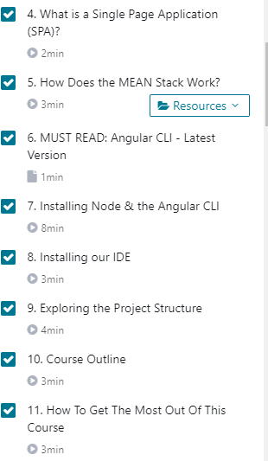

**Coding Challenges Details**:

**program1:**

**struct Node**

**{**

**int data;**

**struct Node* next;**

**};**

**pointer to the new head node. /**

**struct Node reverse (struct Node head, int k)**

**{**

**struct Node current = head;**

**struct Node next = NULL;**

**struct Node prev = NULL;**

**int count = 0;**

**while (current != NULL && count < k)**

**{**

**next = current->next;**

**current->next = prev;**

**prev = current;**

**current = next;**

**count++;**

**}**

**if (next != NULL)**

**head->next = reverse(next, k);**

**return prev;**

**}**

**void push(struct Node** head_ref, int new_data)**

**{**

**struct Node* new_node =**

**(struct Node*) malloc(sizeof(struct Node));**

**new_node->data = new_data;**

**new_node->next = (*head_ref);**

**(*head_ref) = new_node;**

**}**

**void printList(struct Node *node)**

**{**

**while (node != NULL)**

**{**

**printf("%d ", node->data);**

**node = node->next;**

**}**

**}**

**int main(void)**

**{**

**struct Node* head = NULL;**

**push(&head, 8);**

**push(&head, 7);**

**push(&head, 6);**

**push(&head, 5);**

**push(&head, 4);**

**push(&head, 3);**

**push(&head, 2);**

**push(&head, 1);**

**printf("\nGiven linked list \n");**

**printList(head);**

**head = reverse(head, 2);**

**printf("\nReversed Linked list \n");**

**printList(head);**

**return(0);**